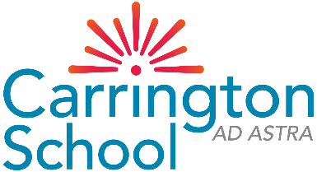
College Interview Preparation Sheet

Why have you chosen these particular courses/subjects? What do you know about the subjects/courses that you are applying for? Does the course fit with a future career aim (if known)? What are your predicted grades? Do they meet the entry requirements for the courses that you have applied for? Do you have any further supporting evidence for these grades (mock exam results)? What are your strengths (what have your teachers said that you are good at?)

Why have you chosen to study at this college? Have you read the prospectus? Have you checked the college website? What information did you look at? Did you attend the virtual open events at the college? What information/videos did you look at? Did you attend the virtual question and answer sessions at the open events?

Student Name
What college(s) have you applied for?
What courses/subjects have you applied for? (Specify for each college if you have applied to more than one)

Are there any questions about the course or the college that you would like to ask the interviewer? Do you want to know more about the college courses and topics that are covered? Do you want to know about clubs that the college offers outside of lessons? Do you want to know what support the college can give you to get a job, find an apprenticeship or get into a good university?

Have you thought what you might like to do after college? Are you intending to go to university (if so, what would you like to study?), have you considered an apprenticeship (if so, in which work area?), do you intend to go straight into work (which types of jobs are you interested in?)

What do you like to do in your spare time? Do you attend any clubs? What are your interests in your spare time? Have you held any positions of responsibility at school (prefect, subject captain etc) or out of school? (organisation of events, sports team captain etc). Have you had any part time jobs or have you conducted any related work experience?

